Abstract, A guideline to how the abstract should look like, when submitted to the Scientific committee, not later than 15 September 2025 for the annual conference 27 January 2026 (Calibri 14, bold)
J.G. Dannisøe, Danish Water Forum*, P.E. Holm**, KU-PLEN, HJ. Albrechtsen, DTU Environment*** (Calibri 10, Italic)

Abstract
Dear author. (Calibri 10)
We suggest that you build your abstract according to the headings below:

Please follow this WORD format, when you submit your abstract to the organising committee. It will help us a lot in joining all abstracts to a booklet. DO NOT SUBMIT IN PDF.
Your abstract must NOT exceed 1 page in total, covering names of authors, pictures and text. When adding pictures, please compress them to a suitable level to avoid very heavy files. DO NOT CHANGE FONT in the main text (Calibri 10).

The meeting will take place 27 January 2026 at University of Copenhagen. Your presentation at the meeting should also be with compressed pictures to avoid heavy files. Send the abstract in WORD to the Scientific committee through Jesper G. Dannisøe, DWF at dwf@danishwaterforum.dk with a copy to jda@dhigroup.com : SUBJECT TITLE: ABSTRACT!

Please expect that you will have approx. 10 minutes for your presentation.

Introduction: State your subject and the context

Methods and data: State what was used as data and tools

Results: Key results from the research/work

Market potential: Consider whether your research results have either a direct market value or could support further research.

Discussion and take-home message: 2-3 key finding and how to apply the results and how to use them.

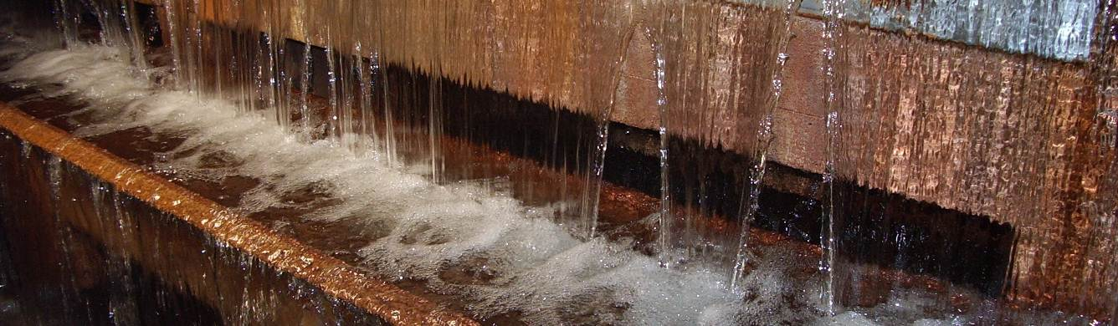

* jda@dhigroup.com: Agern Allé 5, DK-2970 Hørsholm, Denmark
** peho@plen.ku.dk: Thorvaldsensvej 40, 1871 Frederiksberg C
*** hana@env.dtu.dk : Bygningstorvet, Bygning 115, 2800 Lyngby

